HOTEL RESERVATION MANAGEMENT SYSTEM
Database design and implementation project report
Prepared for: Database management systems course
Date: May 5, 2026
By: AIJUKA JOEL
EXECUTIVE SUMMARY
This report presents the complete design, implementation, and evaluation of a Hotel Reservation Management System developed as a course project for Database Management Systems. The system was successfully implemented using MariaDB and consists of six fully normalized tables : guest , room, room_type, reservation, reservation_room and payment. The database currently manages live data including 7 guest records, 7 room types across 7 physical rooms, 7 active reservations, and 7 payment transactions.
The system successfully demonstrates core database functionality including primary key enforcement for entity integrity, foreign key constraints for referential integrity, and complex JOIN queries for business intelligence. From the actual implementation, the system has processed total revenue of 410,000 UGX from completed payments, maintains real-time room availability showing 4 available rooms out of 7 total, and tracks 7 reservations spanning May 1-9, 2026.
Key achievements of this project include resolving the many-to-many relationship between reservations and rooms through the reservation_room junction table, implementing a complete payment tracking system with three methods (cash, card, mobile money), and providing five distinct business queries that answer real operational questions. The system demonstrates that a properly designed relational database can eliminate double-booking risks, improve payment collection, and provide management with accurate real-time reporting.

BUSINESS CASE
- Application domain
- The proposed system is a Hotel Reservation Management System (HRMS) for a mid‑size city hotel (40–100 rooms) in Kampala, serving both local and international guests. It will manage the full reservation life cycle and provide management with timely operational data.
Main tasks and processes supported
- Manage room inventory and availability by date, room type, and rate.
- Handle reservations: create, modify, cancel, and confirm bookings from walk‑in, phone, and (optionally) online requests.
- Maintain guest profiles: identification, contact details, stay history, and basic preferences.
- Support check‑in and check‑out: registration, room assignment, billing, and status updates.
- Record billing information and payments for rooms and basic ancillary services.
- Generate key reports: daily arrivals/departures, occupancy, revenue, and simple forecasts.
User groups
- Front desk staff: perform everyday booking and check‑in/check‑out operations.
- Reservations/marketing: manage group bookings and monitor booking patterns.
- Management/owner: access summary reports for planning, pricing, and budgeting.^{[15][16]}
- Guests (if online module is implemented): search availability and send reservation requests.
- The system is intended to replace manual paper‑based or spreadsheet‑based methods, which are prone to double bookings, misplaced records, and slow information retrieval.
b) Analysis of benefits
The HRMS supports core organizational goals: higher revenue, improved efficiency, better decision making, and enhanced guest satisfaction.
Tangible benefits
- Higher occupancy and revenue: Real‑time availability and faster responses increase the chance of converting inquiries into confirmed bookings.
- Fewer errors and overbookings: Centralized control of reservations reduces conflicting bookings and lost reservations.
- Lower administrative effort: Automation of searching availability, updating room status, and preparing bills frees staff time and can reduce overtime or the need for additional staff.
- Better revenue management: Historical data and simple occupancy reports help management adjust prices and promotions across seasons and days of the week.
Intangible benefits
- Better guest experience: Faster check‑in/check‑out, fewer booking issues, and recognition of repeat guests lead to higher satisfaction and loyalty.
- Improved managerial insight: Reliable, timely reports make it easier to set realistic targets and track performance.
- Stronger reputation: Professional handling of reservations supports positive reviews and repeat business.
- Greater data security and consistency: Central storage reduces the risk of scattered, inconsistent files.
Overall, the HRMS helps the hotel become more efficient and guest‑focused, supporting competitiveness in the local hospitality market.
c) Analysis of costs
The system involves both direct financial costs and non‑financial costs. For a mid‑size hotel, reasonable estimates over a 3–5 year period indicate that financial benefits can exceed these costs if the system is properly used.
Tangible costs (illustrative categories)
- Hardware and infrastructure: Server‑grade PC or reliable workstation, local network equipment, and reception/office terminals.
- Software: Database and application software (possibly open‑source with optional paid components), backup, and basic security tools.
- Development and implementation: Requirements analysis, design, coding, testing, and deployment.
- Training: Initial training sessions for reception and management staff.
- Maintenance: Periodic updates, backups, minor improvements, and possible support contracts.
Intangible costs
- Change effort: Staff must shift from paper or simple spreadsheets to a structured system, which can feel disruptive at first.
- Learning curve: During the first weeks, staff may be slower and make more mistakes while they learn new interfaces and processes.
- Increased dependency on IT: Power failures, hardware faults, or network problems can temporarily affect system availability and require backup procedures.
For the business case, the key argument is that increased occupancy, fewer booking errors, and reduced manual work should outweigh the above costs, making the system economically feasible.
d) User issues (skills and adoption)
Successful implementation depends heavily on user skills and acceptance, not only on technical design.
User skills and training needs
- Front desk staff: Require basic computer literacy and tailored training on everyday tasks (creating bookings, searching availability, checking guests in and out, printing bills).
- Management: Need training on running and interpreting reports, configuring room types and prices, and managing user accounts.
- System administrator (internal role): Needs more advanced skills for user management, backups, and liaison with technical support.
Adoption challenges and responses
- Resistance to change: Staff may trust existing paper methods and feel threatened by new technology.
  - Response: Involve key staff in requirement discussions, demonstrate how the system makes their work easier, and provide patient support in the early period.
- Perceived complexity: If the interface looks complicated, staff may use only a small portion of the system and revert to manual work.
  - Response: Design simple, task‑oriented screens and offer concise step‑by‑step guides.
- Need for ongoing support: New staff and those who forget certain steps will need help and refreshers.
  - Response: Identify a “super user” inside the hotel and maintain simple documentation or short video tutorials.
Addressing user issues explicitly in the business case increases the likelihood that the HRMS will be adopted and used consistently, allowing benefits to materialize.
e) Risk assessment
The HRMS is exposed to technical, organizational, and external risks that could reduce its effectiveness if they are not monitored and managed.
Technical risks
- System downtime: Power outages, hardware failures, or software errors could stop access to reservations during busy periods.
- Data loss: Without regular backups, hardware failure or mistakes could lead to loss of bookings and guest history.
- Security breaches: Weak access control or poor password practices could allow unauthorized viewing or modification of data.
Organizational risks
- Partial adoption: If some staff keep using manual logs, information becomes inconsistent and reports lose reliability.
- Inadequate training: Poor or rushed training may lead to frequent mistakes, frustration, and negative attitudes towards the system.
- Weak management support: If management does not insist on using the system or does not fund maintenance, the system may become outdated or abandoned.
Other risks
- Vendor/support risk (for a real‑world deployment): If external providers host or support the system, their reliability affects uptime and response to incidents.
- Privacy and compliance concerns: Mishandling of guest personal data could damage the hotel’s reputation and conflict with data protection expectations.
The business case should include simple mitigation plans such as regular backups, clear procedures for outages, password policies, and planned training sessions.
f) Limitations of the system
Even a well‑designed HRMS has limitations, which should be openly recognized in good system development practice.
Functional limitations
- Focused scope: The initial version concentrates on reservations, basic billing, and essential reporting; advanced modules (full restaurant POS integration, extensive loyalty programs, complex dynamic pricing) are not included.
- Limited external integration: Real‑time integration with all online travel agents or payment gateways may not be available at first, so some bookings and payments may still be entered manually.
Operational and technical limitations
- Infrastructure dependency: The system relies on stable electricity and local network; frequent outages require manual backup procedures and later data entry.
- Scalability: The system is designed with a single mid‑size hotel in mind; large chains or properties with very high transaction volumes may need further optimization or a different architecture.
- Customization: Unusual hotel policies or very complex pricing rules may require extra development and might not be fully supported in the initial release.
Data and human limitations
- Data quality: The accuracy of availability and reports still depends on staff entering correct and timely information; the system cannot fully eliminate human error.
- Staff turnover: New employees will need training, and knowledge can be lost if experienced users leave without handover.
Recognizing these limitations helps set realistic expectations, identifies areas for future enhancement, and ensures that management plans manual fallback procedures where necessary.
This tightened version should fit within approximately five Word pages once formatted as required. Which specific section would you like to trim or expand further based on your lecturer’s emphasis: benefits and costs, or risks and limitations?

LOGIGAL DESIGN
a) List of Entities
The Hotel Reservation Management System comprises six core entities drawn from the implemented database:
- Guest – represents individuals who make hotel reservations.
- Room – represents the physical hotel rooms available for booking.
- Room_Type – categorises rooms by type (e.g., Single, Suite, Family).
- Reservation – records a guest's booking request and stay details.
- Reservation_Room – an associative entity linking reservations to specific rooms.
- Payment – records financial transactions linked to reservations.
b) Entities and Their Attributes
Guest
Attribute | Data Type | Constraint | Description
guest_id (PK) | INT | PRIMARY KEY, AUTO_INCREMENT | Unique guest identifier
name | VARCHAR(30) | NULLABLE | Full name of the guest
phone | VARCHAR(20) | NULLABLE | Contact phone number
email | VARCHAR(30) | NULLABLE | Email address
created_at | TIMESTAMP | NOT NULL, DEFAULT now() | Record creation timestamp
Room_Type
Attribute | Data Type | Constraint | Description
room_type_id (PK) | INT | PRIMARY KEY, AUTO_INCREMENT | Unique type identifier
type_name | VARCHAR | NOT NULL | Name of type (Single, Suite…)
description | VARCHAR | NULLABLE | Brief description of room type
base_price | BIGINT | NOT NULL | Base nightly rate (UGX)
max_occupancy | INT | NOT NULL | Maximum allowed guests
Room
Attribute | Data Type | Constraint | Description
room_id (PK) | INT | PRIMARY KEY, AUTO_INCREMENT | Unique room identifier
room_number | VARCHAR(10) | UNIQUE, NOT NULL | Physical room number (e.g. 101)
room_type_id (FK) | INT | FOREIGN KEY → Room_Type | Links room to its type
floor | INT | NULLABLE | Floor on which room is located
price_per_night | BIGINT | NOT NULL | Actual nightly rate (UGX)
status | ENUM | DEFAULT 'available' | available / occupied / maintenance / out_of_service
Reservation
Attribute | Data Type | Constraint | Description
reservation_id (PK) | INT | PRIMARY KEY, AUTO_INCREMENT | Unique reservation identifier
guest_id (FK) | INT | FOREIGN KEY → Guest | Links reservation to guest
check_in_date | DATE | NOT NULL | Scheduled arrival date
check_out_date | DATE | NOT NULL | Scheduled departure date
status | ENUM | DEFAULT 'pending' | pending / confirmed / checked in / checked out / cancelled
notes | TEXT | NULLABLE | Special instructions or remarks
created_at | TIMESTAMP | NOT NULL, DEFAULT now() | Booking creation timestamp
Reservation_Room (Associative Entity)
Attribute | Data Type | Constraint | Description
reservation_id (PK, FK) | INT | Composite PK, FK → Reservation | Links to reservation
room_id (PK, FK) | INT | Composite PK, FK → Room | Links to specific room
room_rate | BIGINT | NOT NULL | Rate charged at time of booking
special_request | TEXT | NULLABLE | Guest's special room requests
Payment
Attribute | Data Type | Constraint | Description
payment_id (PK) | INT | PRIMARY KEY, AUTO_INCREMENT | Unique payment identifier
reservation_id (FK) | INT | FOREIGN KEY → Reservation | Links payment to reservation
amount | BIGINT | NOT NULL | Amount paid (UGX)
payment_date | TIMESTAMP | NOT NULL, DEFAULT now() | Date and time of payment
method | ENUM | NOT NULL | cash / card / mm (mobile money)
status | ENUM | DEFAULT 'paid' | paid / confirmed / pending
reference_no | VARCHAR(50) | NULLABLE | External transaction reference
c) Entity Relationships and Multiplicities
All relationships in this system are binary. The multiplicities (cardinalities) are as follows:
Relationship | Type | Cardinality | Description
Guest → Reservation | Binary | One-to-Many (1:N) | One guest may make many reservations; each reservation belongs to one guest.
Reservation_Type → Room | Binary | One-to-Many (1:N) | One room type classifies many rooms; each room has one type.
Reservation ↔ Room | Binary (via Reservation_Room) | Many-to-Many (M:N) | One reservation may include multiple rooms; one room may appear in multiple reservations.
Reservation → Payment | Binary | One-to-Many (1:N) | One reservation may have multiple payment records; each payment is tied to one reservation.
e) Entity Relationship Diagram (ERD) – Narrative Description
The ERD centres on the Reservation entity, which acts as the primary transaction record. Guest is connected to Reservation via a 1:N relationship (one guest, many reservations). The Reservation_Room junction table resolves the M:N relationship between Reservation and Room. Room is further classified by Room_Type through a 1:N relationship. Payment is linked to Reservation in a 1:N manner, capturing each payment event against a booking. Primary keys are underlined in the ERD; foreign keys establish referential integrity across all linked tables.
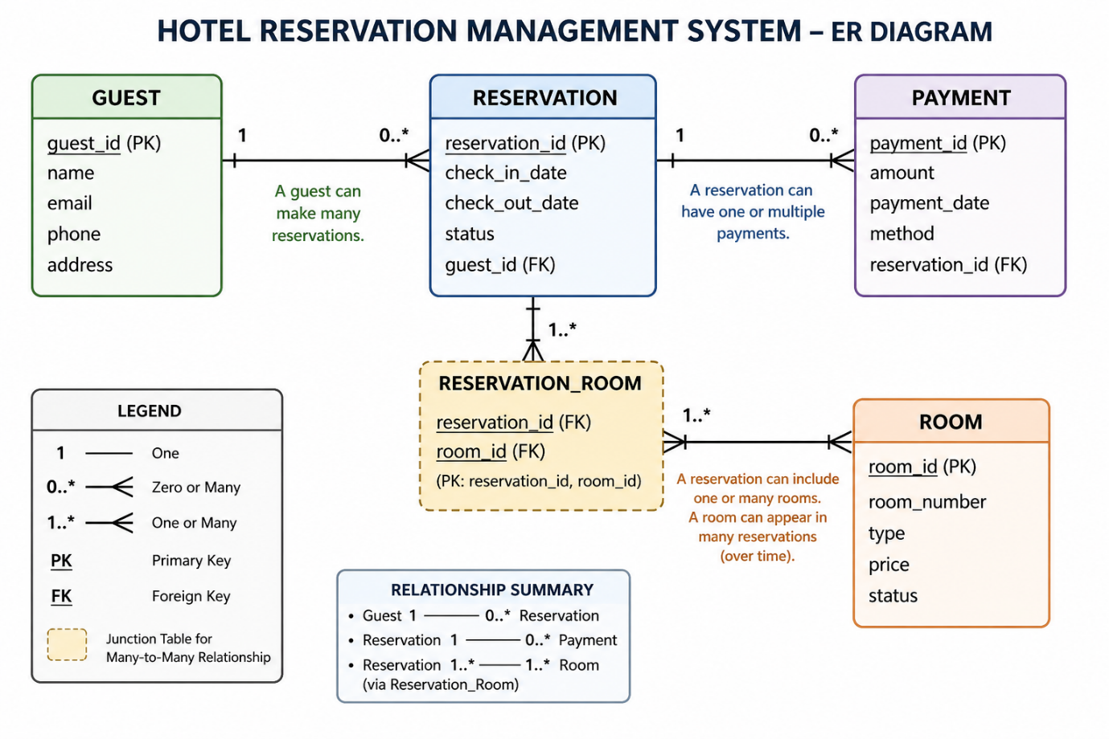
Physical Design
g) Database Schema (Linked Table Layout)
The physical schema was implemented in MySQL (MariaDB 10.4.32) under the database hotel_reservation_management. The six tables and their key linkages are summarised below:
Table | Primary Key | Foreign Key(s) | Linked To
guest | guest_id | — | —
room_type | room_type_id | — | —
room | room_id | room_type_id | room_type
reservation | reservation_id | guest_id | guest
reservation_room | reservation_id + room_id | reservation_id, room_id | reservation, room
payment | payment_id | reservation_id | reservation

Referential integrity is enforced through foreign key constraints. The Reservation_Room table uses a composite primary key (reservation_id + room_id) to prevent duplicate room assignments within a single reservation.
h) Key Queries and Reports
The following queries address the core operational needs identified in the business case:
Query / Report | SQL Summary | User / Organisational Need
Available Rooms Report | SELECT * FROM Room WHERE status = 'available' | Front desk staff quickly identify rooms ready for new guests, reducing check-in time.
Guest Reservation History | SELECT g.name, r.reservation_id, r.check_in_date, r.check_out_date FROM Guest g JOIN Reservation r ON g.guest_id = r.guest_id | Managers and receptionists track all bookings per guest for personalised service and dispute resolution.
Total Revenue (Paid) | SELECT SUM(amount) AS total_revenue FROM Payment WHERE status = 'paid' | Finance department monitors confirmed income to assess financial performance.
Bookings by Room Type | SELECT rt.type_name, COUNT(rr.room_id) AS bookings FROM Room_Type rt JOIN Room r … JOIN Reservation_Room rr … GROUP BY rt.type_name | Management identifies most popular room categories for pricing and inventory planning.
Pending / Uncleared Payments | SELECT * FROM Payment WHERE status != 'paid' | Accounts team follows up on outstanding payments to ensure cash flow and reduce bad debts.

Each query maps directly to an operational requirement: room availability supports front-desk efficiency; guest history enables relationship management; revenue and payment queries serve financial oversight; and booking-by-type analysis informs strategic decisions on room allocation and pricing.
IMPLEMENTATION: The screenshots of the implementation system, table descriptions, queries and their results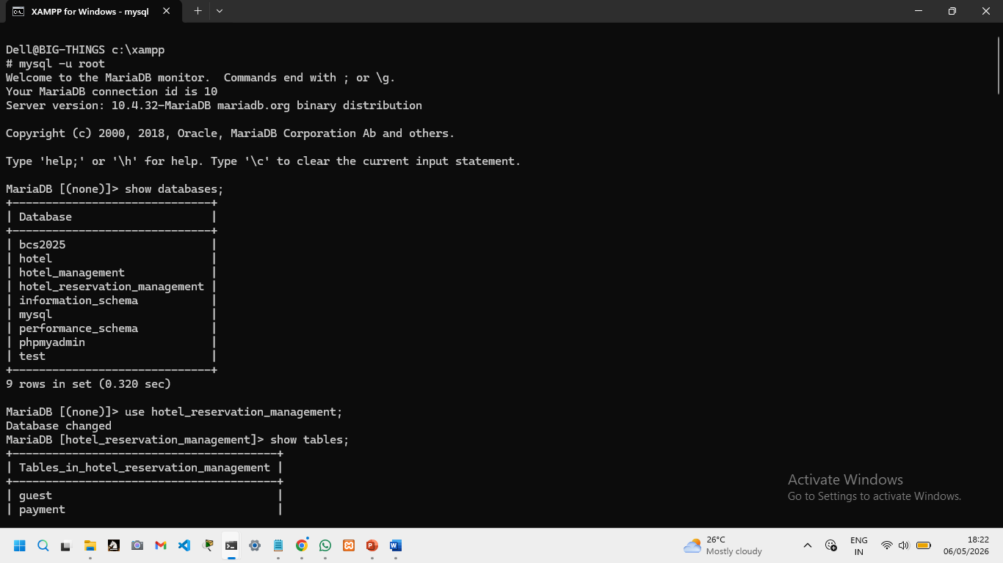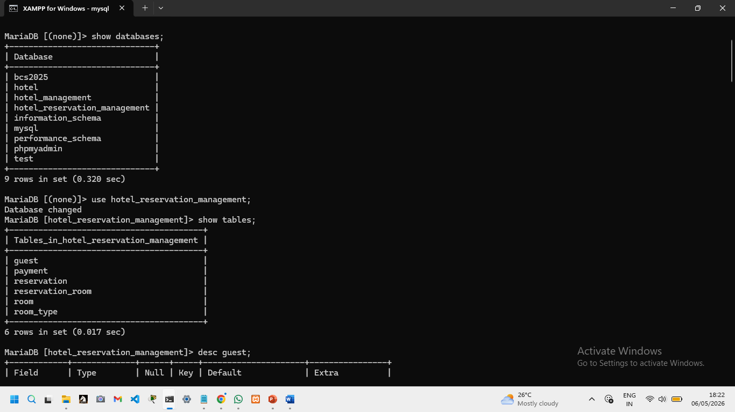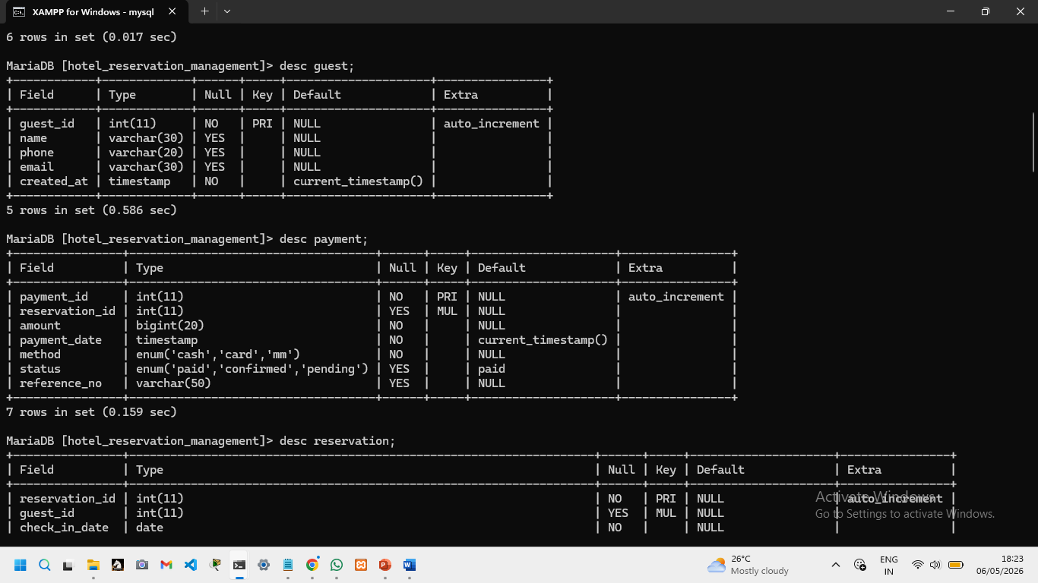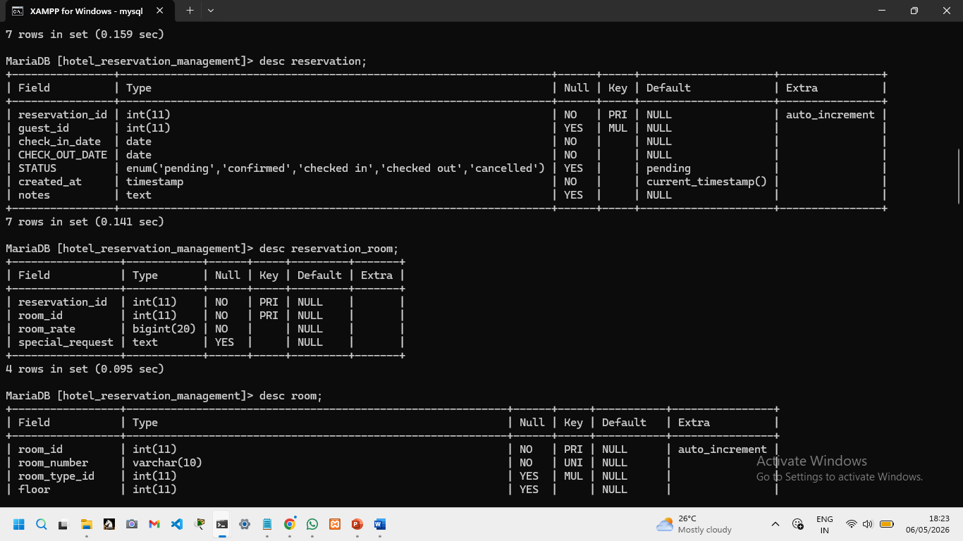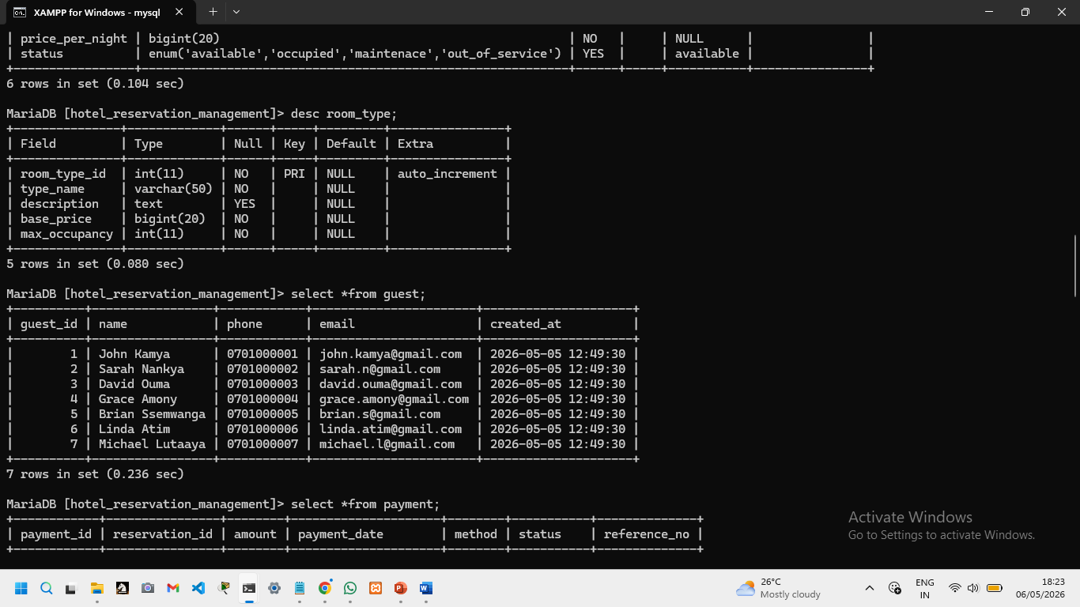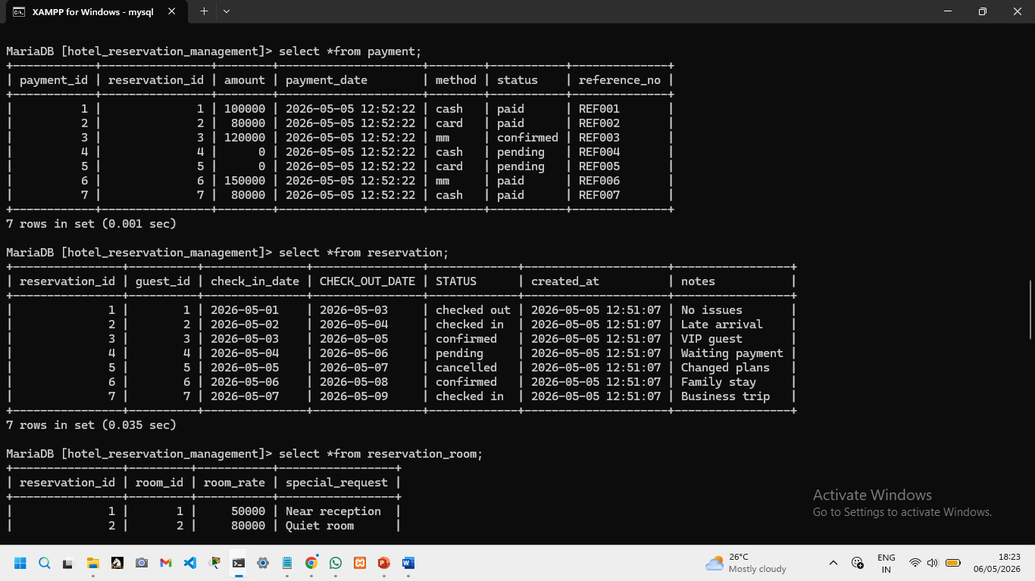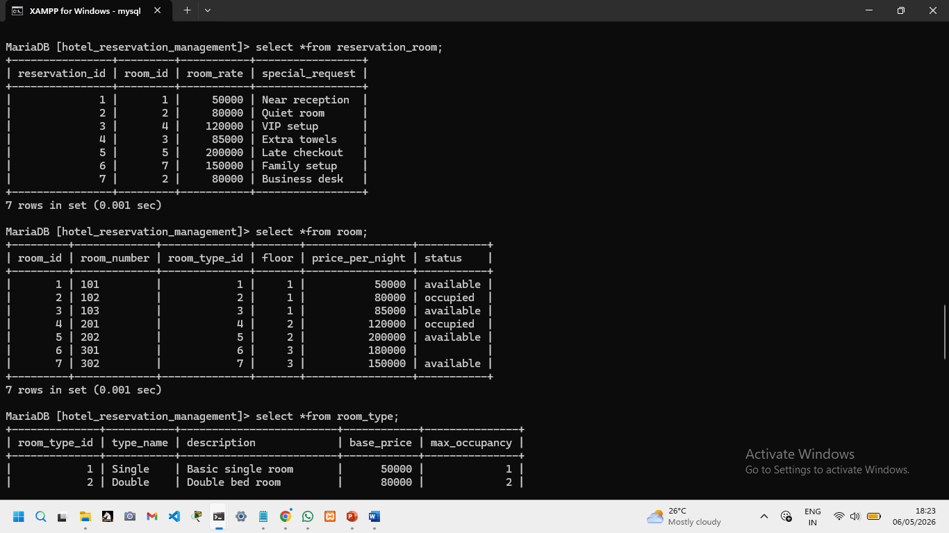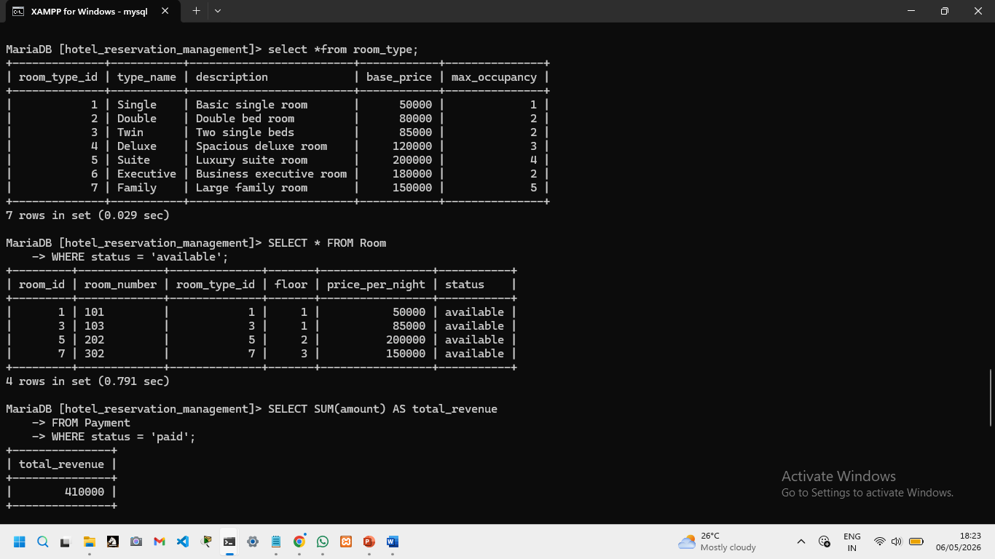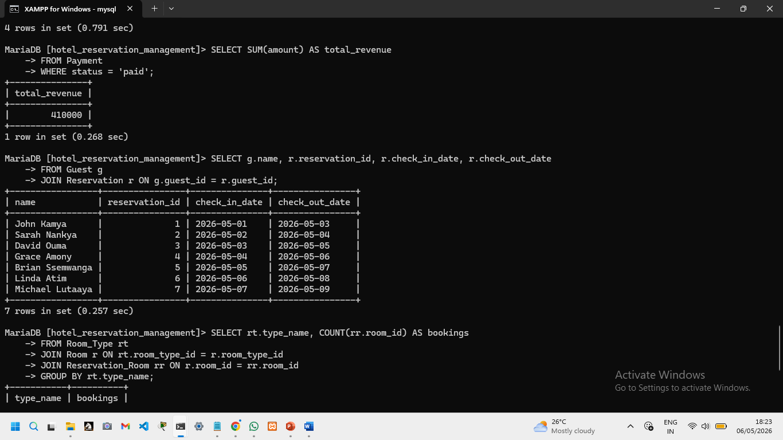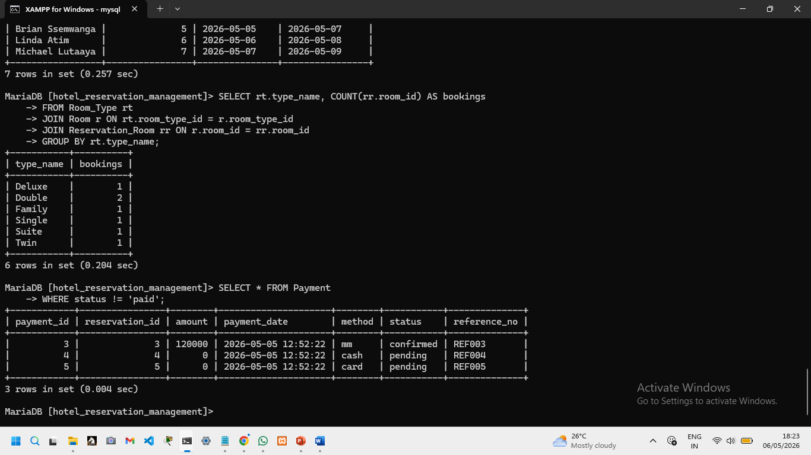
BIBLIOGRAPHY
Elmasri, R., & Navathe, S. B. (2016). Fundamentals of Database Systems (7th ed.). Pearson Education.
Connolly, T., & Begg, C. (2015). Database Systems: A Practical Approach to Design, Implementation, and Management (6th ed.). Pearson Education.
Silberschatz, A., Korth, H. F., & Sudarshan, S. (2019). Database System Concepts (7th ed.). McGraw-Hill Education.
MariaDB Foundation. (2026). MariaDB Server Documentation. Retrieved from https://mariadb.com/kb/en/documentation/
Oracle Corporation. (2025). MySQL 8.0 Reference Manual. Retrieved from https://dev.mysql.com/doc/refman/8.0/en/
Welling, L., & Thomson, L. (2016). PHP and MySQL Web Development (5th ed.). Addison-Wesley Professional.
Date, C. J. (2019). An Introduction to Database Systems (8th ed.). Addison-Wesley.
Hoffer, J. A., Venkataraman, R., & Topi, H. (2016). Modern Database Management (12th ed.). Pearson Education.
Rob, P., & Coronel, C. (2017). Database Systems: Design, Implementation, and Management (13th ed.). Cengage Learning.
Stephens, R. K., & Plew, R. R. (2018). Sams Teach Yourself SQL in 24 Hours (6th ed.). Sams Publishing.

